CHAPTER III

Why There Are Two Tides a Day

Introduction

Anyone who spends time near the sea knows about tides. The sea level rises and falls daily and it seriously affects the daily routine for many people. In Normandie, France, there is sometimes as much as 12 metres water-level difference between high and low tide, which corresponds to a distance of over 1 km across the beach. It is a good time to go digging for shellfish. And in World War II the timing of the Normandy landings (fig. 1) was seriously linked to the tides.

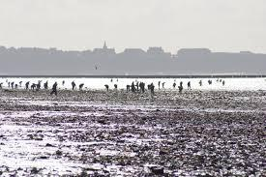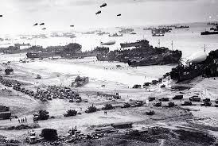

Fig. 1. The Normandy landings. Note that the tide is very low. OUP: I DON'T KNOW WHERE THESE IMAGES COME FROM

The cycle of tides appears to be once per day and it makes sense because we are told that the tides are caused by the gravitational pull of the moon, which goes around the earth once per day. But we’re mistaken! While we sleep the tide comes up and goes down once again – there are two tides per day. Explaining this isn’t easy. Here we tread carefully and admit the existence of “centrifugal force” – many physicists will gasp in shock at the mere mention of this fictitious concept. But Einstein himself says, in General Relativity, that gravity and acceleration are indistinguishable so if you deny the existence of centrifugal force then gravity goes out the window as well!

The moon goes around the Earth – but the Earth orbits the moon as well. It is the balance of gravity with centrifugal force that keeps the centres of both bodies in perfect circular motion. But any water on the side of the Earth closer to the moon gets pulled more strongly by gravity and water further away from the moon has a stronger centrifugal force. This leads to two ‘bulges’ of water. We therefore see two high tides per day as the Earth rotates about its axis.

The reason why there are two tides a day, rather than the obvious single high tide due to the gravity of the moon, has attracted numerous explanations and a good deal of controversy. The explanation is not straightforward as the tidal force is the small difference between two larger forces. If we calculate the force on a mass at the surface of the earth, for example, that due to the sun is 178 times greater than that due to the moon. This is why the earth orbits the sun and not the moon. Also, the connection between forces acting on a fluid and the resulting formation of the surface is far from obvious. The test of any theory is whether it can predict the size of the tides, and we show how this can be done from the two main types of explanation, although the algebra must be handled with care and an appreciation of the approximations involved.

The most physically accessible explanation is to consider the centrifugal force due to the rotation of the earth about the centre of gravity of the moon-earth system. This has been criticised on two grounds. Firstly, that the concept of centrifugal force does not exist and secondly that it would be a remarkable coincidence if the centrifugal force was just that required to balance the moon’s gravitation. The second criticism is obviously wrong, the period of rotation of the earth moon system is exactly that required to balance the moon’s gravitational force at the centre of the earth, so the effects are not independent.

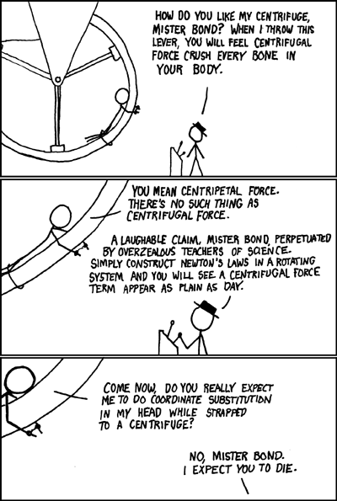

Fig. 2. The centrifugal/centripetal force debate.

The first criticism is more a matter of taste, as satirised in fig. 2. It is a common and powerful technique in solving mechanical problems to transfer to a rotating frame of reference, which adds a centripetal and Coriolis acceleration to the analysis. The problem can then be converted into an easier statics problem by replacing these accelerations with equal and opposite forces, or so-called d’Alembert forces. This is a completely rigorous and intuitively attractive approach. Most of the contumely attracted by this method is from people who miss a crucial step in the argument, which is that we need to consider the situation when the earth and moon rotate as a solid body so that there is only one angular velocity, i.e. the period or ‘day’ of rotation is one month. The result then applies to any length of day since the rate of rotation of the earth on its axis does not affect the tides. A good illustration of the reality of centrifugal force is given in fig.2. [See ref. 1., taken from http://xkcd.com/123/ (cntrl click)]. Fig. 3. Shows the earth orbiting the moon and the moon orbiting the earth. They act as a solid body rotating around the centre of gravity.

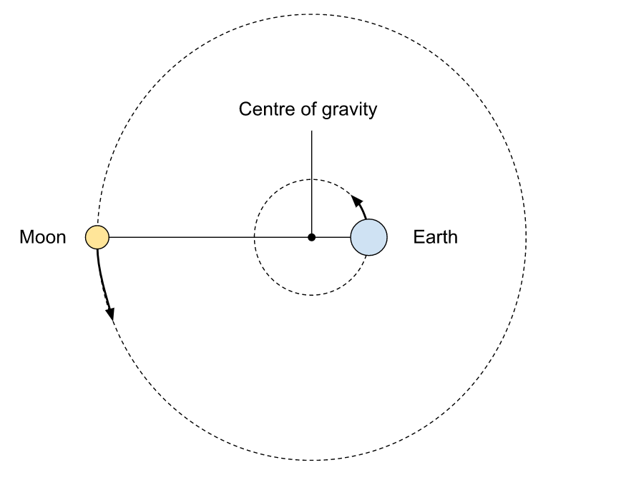

Fig. 3. The earth orbiting the moon and the moon orbiting the earth.

Fig. 4 shows the forces involved in fig. 2. The centrifugal force at the centre of the earth is equal to the gravitational force of the moon. If we travel towards the moon, the gravitational force increases whilst the centrifugal force decreases, so there is a bulge in the level of water. If we travel away from the moon, the centrifugal force increases while the gravitational force decreases, hence another bulge in water level.

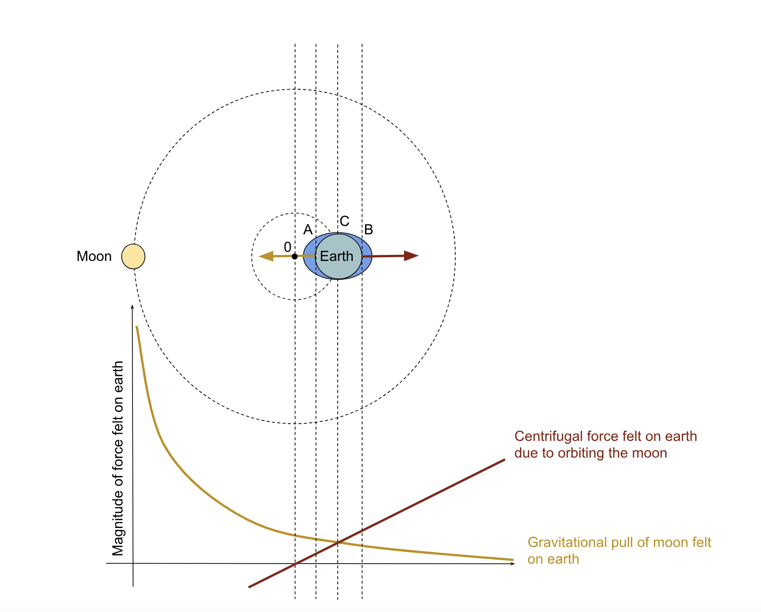

Fig. 4. Bulge in levels of water as due to the difference in forces experienced on either side of the earth.

The second type of explanation invokes the difference in the moon’s gravitational effect across the earth plus the idea that the earth is continuously falling towards the moon (it never gets there because of the sideways motion).

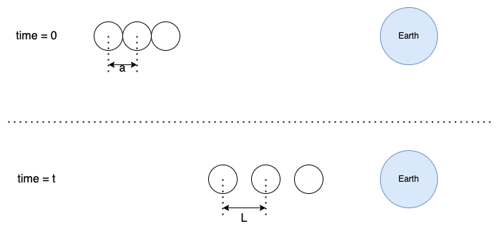

Fig. 5. Three masses initially in contact and after a time t.

Figure 5 shows three small bodies of unit mass, initially in contact, attracted by a mass M. Their accelerations, starting with the left-most, are MG/(d+a²), MG/d² and MG/(d-a)². After a short time t, they become separated by a distance L=t²a/d³ and, to first order, the bodies are still symmetric about the centre mass. The Schumacher Levy comet approaching Jupiter was pulled apart as a result of these forces. Fortunately, our moon is less disruptive and just produces a symmetric bulge, which is static because of the added orbital velocity.

Tide Height from Hydrostatic Pressure

We can now calculate the height of the tides from the two models. However, for the pedants referred to above, here is an exactly equivalent derivation of the tidal heights that avoids using the centrifugal force. It is based, instead, on the well-known pressure gradient in a fluid flowing in a curve with angular velocity ω, as shown in Fig. 6.

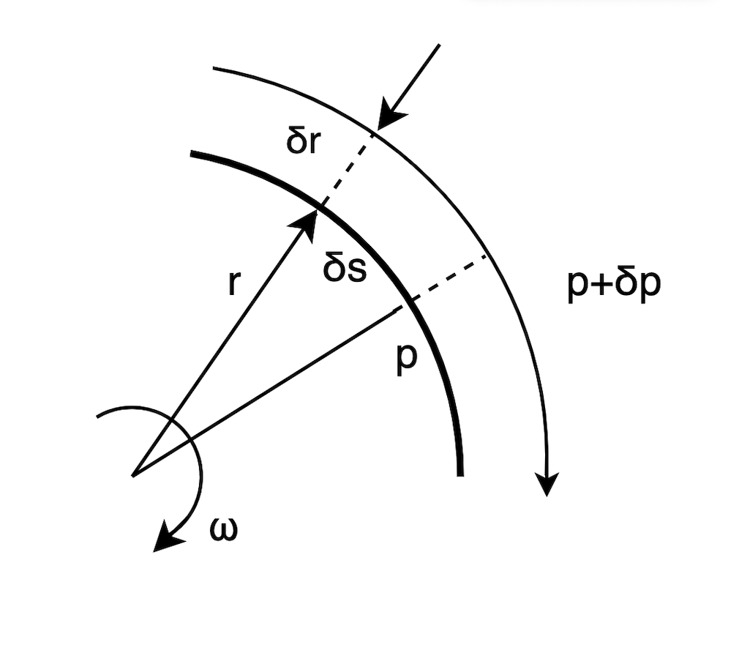

Fig. 6. The pressure gradient in curved stream-lines.

The mass between the dotted lines is ρδrδs, where ρ is the density, p is pressure and s is area. The force on the mass is δpδs. Putting this equal to the centripetal acceleration ω²r multiplied by the mass and rearranging gives dp/dr= ρω²r. By integration, the rise in pressure along the radius from the centre of rotation is then;

½ ρω²r² + constant

The other source of pressure is due to the effect of gravity. Parallel to the gravitational force dp/dx = −ρg, where g is the local force of gravity per unit mass, is the normal hydrostatic pressure. Then p = –ρgx + constant where x is the distance along the gravitational force.

For a gravitating sphere of mass M near the surface:

dp/dr = −ρMG/r² so p = ρMG/r + constant

This is the same as the gravitational potential, but with opposite sign.

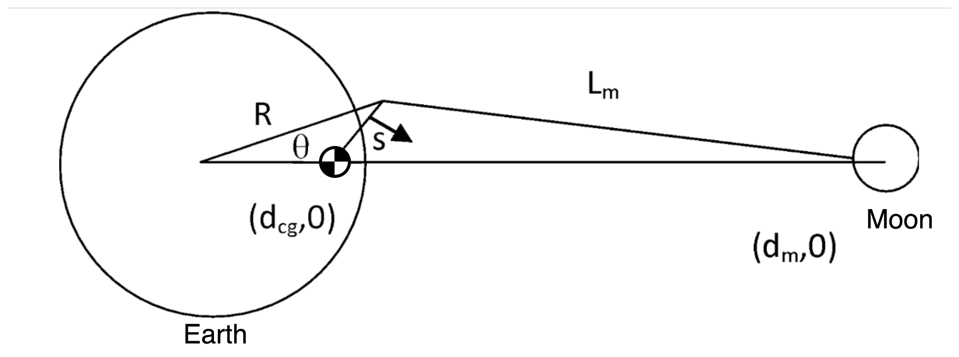

Fig. 7. Distances between the earth and moon used to calculate the height of tides using pressure.

In terms of the distances shown in fig. 7, the pressure is:

where M_{e} and M_{m} are the masses of the earth and the moon. The distance to the centre of gravity is s. p (= constant) gives the contour of the ocean. It can be seen that the expression is identical to the sum of the potentials due to the gravitational and centrifugal forces. The rest of the derivation is merely algebra, although it requires some skill to avoid becoming bogged down. First we substitute for d_{cg} and ω;

If we now write the pressure in normalised units (i.e. divide distances by R_{e}, masses by M_{e} and pressure by G and put m = M_{m} /M_{e} and r = R/R_{e} and d = d_{m}/R_{e}) reduces this to;

(1)

The first term is the hydrostatic pressure due to the earth, the second term is that due to the moon and the third term is the pressure due to the rotation of the ocean round the common centre of gravity.

The simplest way of obtaining the height is to realise that the pressure gradient at the earth’s surface is unity, so the height is equal to the pressure in reduced units. Expanding the second term along the y axis, since d is large gives;

p(1,π/2)-p(1,0) = 3/2 m/d³

multiplying by R_{e} then gives a height of 54 cm.

Along the x axis;

p(1,0)-p(1,π) = 4m/d⁴

which, in real units, is 12 mm.

Hence the high tides below, and furthest from, the moon differ by 12 mm and the height of the tide from low to high water is 54 cm.

This is the true oceanic value but bears little relation to the tidal range in coastal waters where the wave mounts up as the depth decreases. It is commonly stated that the largest tides are in the bay of Funday in Nova Scotia with a peak of about 16 metres, although other sites claim comparable tides. The comparison is not straightforward as tide heights vary over a wide range in the same place and are affected by wind and other weather conditions. The fastest tidal inrush is in the bay of Mont Saint Michel in Normandy where the Seine enters the Channel, creating a large flat sandy estuary. Here the tide comes in faster than a galloping horse over 15 miles, although this is faster than the Froud Number predicts (the wave equivalent of the sound velocity). This is probably because even at low tide the sands are saturated with water just below the surface. As the pressure rises out to sea the water table rises vertically so that on a flat surface the boundary between liquid and solid expands at a rate which tends to infinity as the surface tends to the horizontal. The extreme danger of such situations was shown by the death of thirty Chinese cockle pickers caught out by the tide in Morecombe Bay in 2004. We do not see significant tides in lakes because the opposite shores are much closer together than the earth’s diameter so the variation of the moon’s gravity across them is negligible (and the density of water is constant).

Tide Height from Relative Accelerations

We can obtain the same result by considering the relative accelerations. In this approach, the maths is more direct but, inevitably, more sophisticated. The following derivation is based on ref. 2 and uses vectors.

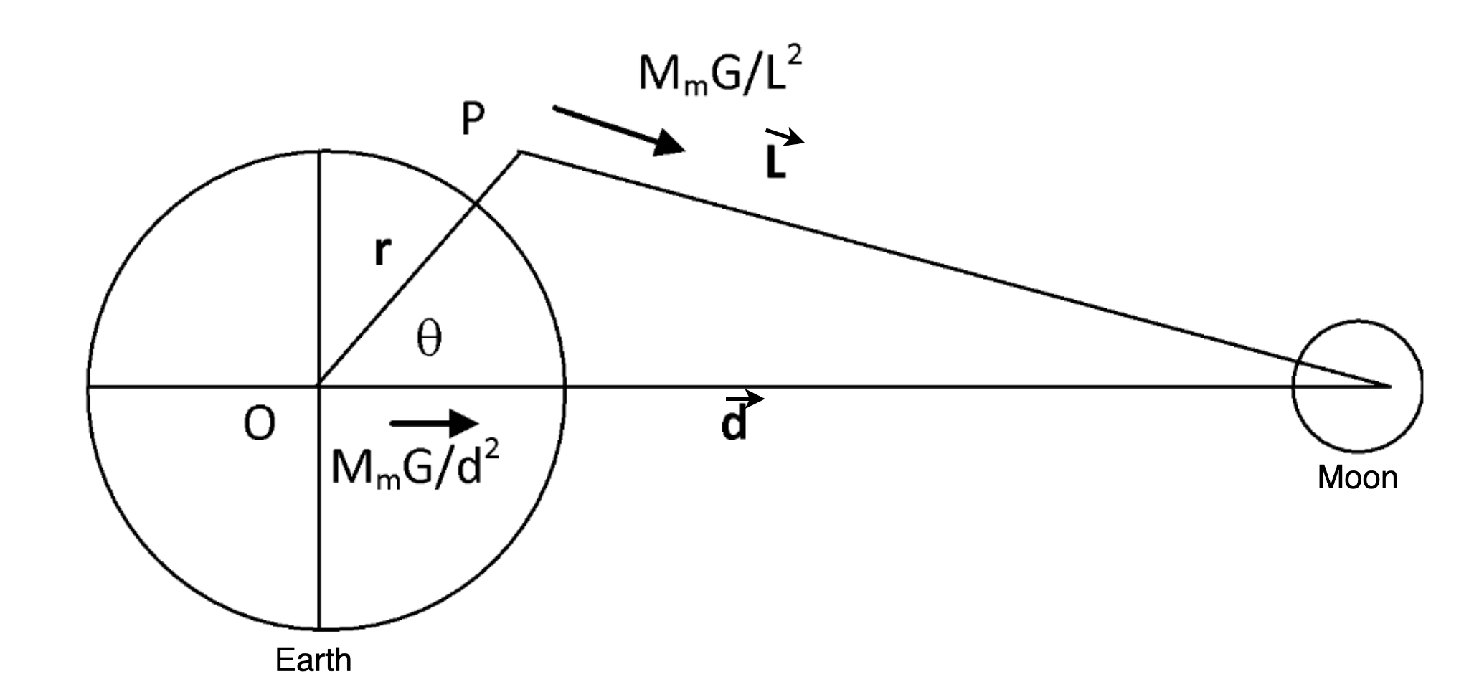

Fig. 8. Distances between the earth and moon used to calculate the height of tides using acceleration. The accelerations at P and O with the vector distances are shown.

We write down the accelerations due to gravity at the points O and P shown in fig. 8.

Acceleration at O; a_{o} = M_{m}Gd/d³

Acceleration at P; a_{p} = M_{m}GL/L³

From the cosine rule; L² = r²+d² – 2rd cos(θ)

Since d >>r;
1/L³=1/d³ +3r cos(θ)/d⁴

Also, L= d-r.

Hence the acceleration a at P in the earth frame of reference is;

It can be seen the resultant accelerations have a horizontal component (parallel to the earth’s surface) that tends to squeeze the oceans into a symmetric ellipse with peaks at points closest to and furthest from the moon, as illustrated in fig. 9.

To find the position of the surface, we need the horizontal component of the acceleration a_{h}

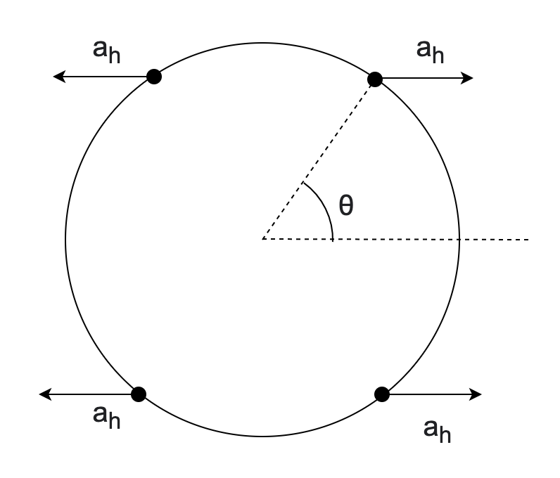  _{(a)} | 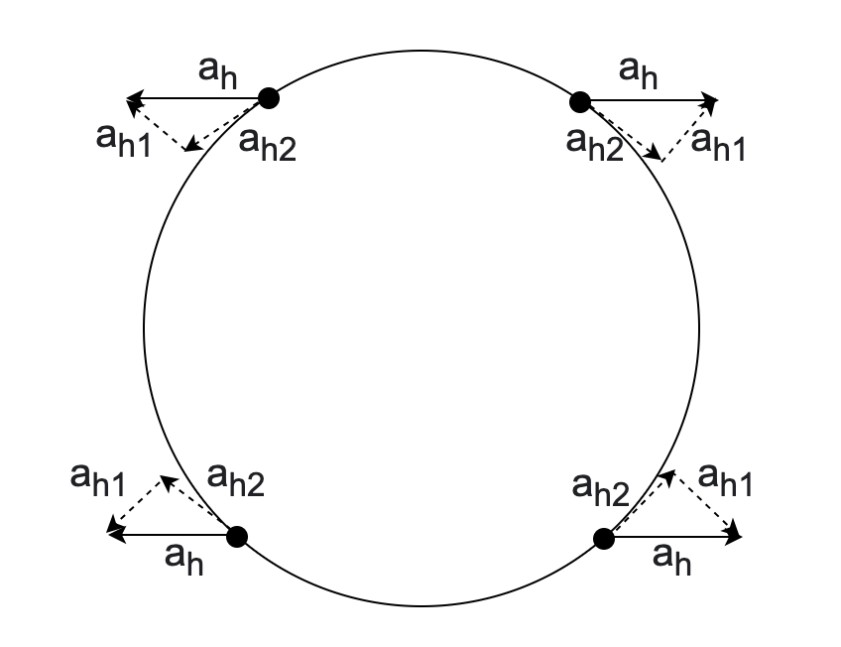  _{(b)} | 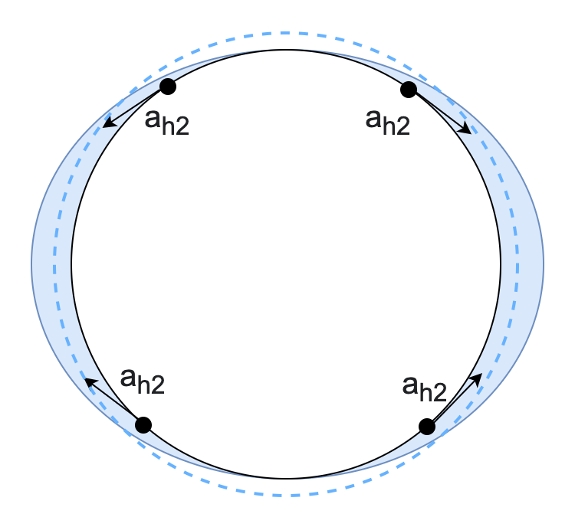  _{(c)}

Fig. 9. The components and resultant accelerations at four points on the earth’s surface. (a) Accelerations relative to the earth due to the forces from the moon. (b) accelerations resolved tangential and radial to the surface. (c) Tangential components are responsible for moving water on the surface of the earth.

This is the acceleration of a mass at P in the reference frame of the earth, parallel to its surface. Since the water does not move, this must be balanced by the force of the earth’s gravity on the sloping face, as shown in fig. 10.

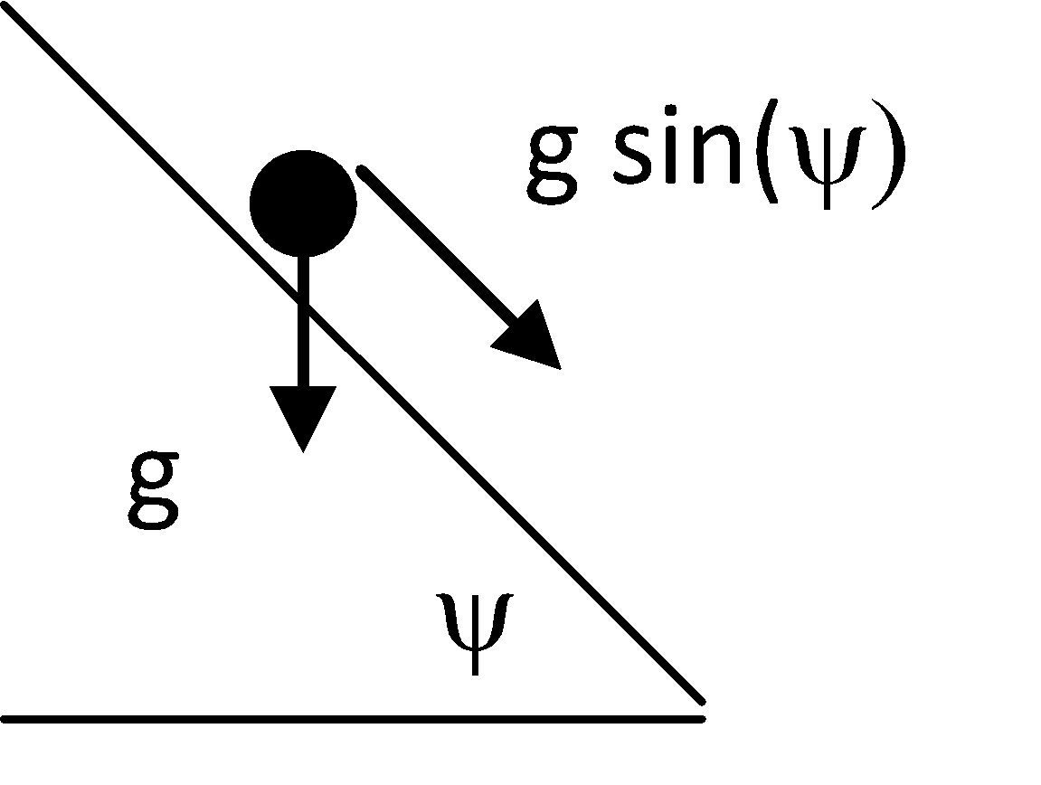

Fig. 10. The acceleration is balanced by gravity at a slope ψ.

A particle on the surface can only move down the surface and is propelled by a force of gsin(ψ). Since the sea is static, this equals the horizontal acceleration derived above (since ψ is small).

Hence, if the height of the tide is h (small compared with R_{e}), then;

Integrating gives;

The two high tides (θ = 0 θ = π) are the same in this approximation, and the tidal range (θ = 0 το θ = π/2) is as before.
We see that three explanations of tides, centrifugal force, hydrostatic pressure and relative accelerations are all equally valid and can give the correct value for the height of the tides.

Ref. 1 http://xkcd.com/123/ (cntrl click).
Ref.2. lectures by Bjørn N. Gjevik of the Department of Mathematics, University of Oslo,

